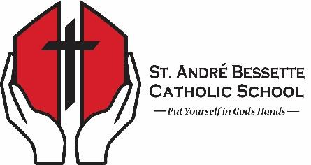
8300 Southfort Drive
Fort Saskatchewan, AB T8L 0W4
Phone: 587-744-0750

St. André Bessette Catholic School
Student Attire Guidelines

Students recognize that St. André Bessette Catholic School is a professional, faith-based educational environment, and therefore must take this into consideration when dressing from day to day. We are a Catholic School, where we have the ability and opportunity to express ourselves, but we must also remember the context of our environment and must be reasonable with what we wear.

Students will consider the following guidelines when dressing for school:
- Hats, hoods, and toques can be worn in the hallways, but will be taken off in class, during prayer, mass and assemblies.
- Clothing that displays or promotes illegal items such as alcohol, drugs, tobacco, sex, profanity, obscenity, or racism is not allowed.
- No underwear should be shown, and shorts and skirts should cover the buttocks.
- Crop tops are fine but should cover the belly button if the midriff is uncovered.
- Camisoles or tank tops should be worn underneath sheer shirts.
- Necklines must have an appropriate amount of coverage.

The Dress Code Committee, consisting of both students and staff, have written this attire policy in the 2017-18 school year. It has been agreed that students have the responsibility to govern themselves appropriately, however staff will also assist in adherence to these guidelines so as to continue to uphold the professional, faith-based learning environment that has been created in our school.

